**SL Unit 3** **– Networks**  
Test 1

1. A wireless local area network (WLAN) is used to extend access to a school’s wired

local area network.

1. Identify **one** hardware component of the WLAN, other than computers. [1]

*Award up to* ***[1 max]****.*

Wireless router/modem;

Access points;

Switch;

Wireless repeater/extender/booster;

The advantages of this WLAN are user-mobility and economical access points.

1. Outline **two** disadvantages of this WLAN. [4]

*Award* ***[1]*** *for identifying a disadvantage and* ***[1]*** *for an expansion, for* ***two***

*disadvantages up to* ***[4 max]****.*

Data transfer will decrease (compared with a wired LAN);

Because the number of computers using the network increases;

(and because) WLAN has lower bandwidth than a wired LAN;

Less data security;

As devices from outside the school can access the network/intercept

transmissions;

More easily open to misuse;

As teacher/administrator cannot directly monitor a specific student/teacher/

machine;

Intermittent connectivity due to physical barriers (walls);

Results in low transfer/speed and may hinder operations.

***Note:*** *Accept any reasonable points, provided they are appropriately*

*elaborated.*

1. Identify **three** ways in which the network administrator can reduce the risk of   
   unauthorized access to confidential data. [3]

*Award up to* ***[3 max]****.*

Give each user appropriate login details/passwords;

Different access rights for students, teachers, school administrators (file-level and

share-level security);

All passwords and files should be encrypted;

Use the latest WiFi protocol/WPA2;

Require MAC address authentication;

Password protect the documents;

***Note:*** *the focus of the question is on confidential data (firewalls not accepted)*

The concept of packet data transmission is used within this network. Figure 1 shows the   
 simplified structure of a data packet.

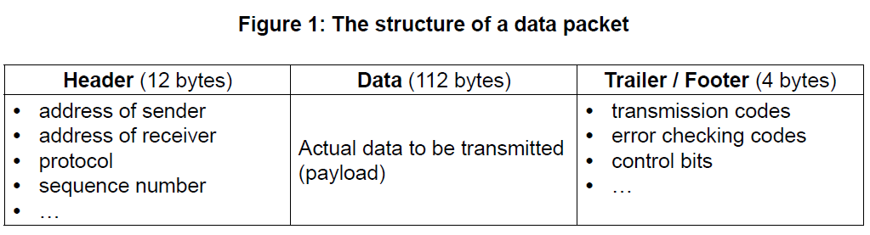

1. Define the term protocol. [1]

Set of rules for data transmission;

1. With reference to **Figure 1**, explain how data is transferred by packet switching. [6]

*Award up to* ***[6]*** *as follows:*

*Award up to* ***[3 max]*** *for a general description of how data is transferred by*

*packet switching. ([1 max] if this general description is very simplistic and refers*

*to just the Header/Data/Trailer already shown in the question paper).*

*Award up to* ***[3 max]*** *for added detail that references the contents of the given*

*data packet in the answer.*

***Example of general description***

Data is organized in specially formatted units (data packets) which are routed

from source to destination using network switches and routers;

Network switches and routers determine how best to transfer the packet between

a number of intermediate devices (routers and switches) on the path to its

destination (rather than flowing directly over a single wire on the path to its

destination);

Data packets are reassembled at the destination;

***Example of referencing content***

***Addresses*** have to be in a standard format so that each switch/routing station

recognizes the address;

***Address of sender*** identifies the sending computer, so that any packets not

received can be re-requested;

***Address of receiver*** identifies intended recipient so it can be forwarded on

correctly;

The ***protocol*** used must be identified so that the correct rules are followed;

***Size of packet / size of fields in packet*** – All packets/fields must have the same

size so that the data can be reassembled;

***Sequence number*** so that packets can be reassembled in correct order;

***Transmission codes*** to show whether the data packet is transmitted or

re-transmitted;

***Control bits****,* to maintain the integrity of the data by ensuring that the data

received is the same as the data sent;

***Error checking code*** – when an error is detected, an algorithm either corrects

the error or requests that the packet is resent;

1. Outline the features of a virtual private network (VPN). [2]

*Award up to* ***[2 max]****.*

VPN transmission is always encrypted / provides a secure connection;

Establishes the tunnel between sender/receiver;

Sender/receiver is authenticated before sending/receiving;

VPN users have access to all services available;